Table of Contents

CHAPTER 1 2

1.1: Problem Statement 2

CHAPTER 2 4

2.1: Coding 4

2.1.1: Codes used in the About Form 4

2.1.2: Codes used in the Agent Earnings Form 5

2.1.3: Codes used in the Agents Form 11

2.1.4: Codes used in the Company Expenses Form 17

3.1.5: Codes used in the Company Income Form 23

2.1.6: Codes used in the Employees Form 29

3.1.7: Codes used in the Estates Form 35

3.1.8: Codes used in the Landlords Form 42

3.1.9: Codes used in the Menu Form 48

3.1.10: Codes used in the Remittance Form 56

3.1.11: Codes used in the Rent Payment Form 62

3.1.12: Codes used in the Splash Screen 70

3.1.13: Codes used in the Tenancy Agreement Form 71

3.1.14: Codes used in the Tenants Form 78

CHAPTER 4 86

4.1: User Manual 86

4.1.1: Introduction 86

4.2: Using the System 86

4.2.1: Command Names 86

4.2.2: Main Menu Manual 87

4.2.3: Agent Earnings Form Manual 88

4.2.4: Agents Form Manual 89

4.2.5: Company Income Form Manual 90

4.2.6: Estate Form Manual 91

4.2.7: Remittance Form Manual 92

4.2.8: Rent Payment Form Manual 93

# CHAPTER 1

# 1.1: Problem Statement

**DOUBLE A PROPERTY MANAGEMENT SYSTEM**

Double A is a property management firm which allocates vacant houses to tenants and collects rent on behalf of landlords.

Currently, the firm manages houses in estates classified as: low income, middle income and high income. The low income estates have small and medium size houses. The middle income estates have medium size and big houses. The high income estates have big houses only. Rent for small houses range from Ksh 3,000 to Ksh 8,000 per month, medium houses range from Ksh 8,000 to Ksh 15,000 and big houses cost above Ksh 15,000.

Some landlords own different sizes of houses located across the various estates.

A person interested in a house visits the office and inquires from the receptionist on the availability of a house in the estate of interest. If there is a vacant house, the potential tenant is referred to the agent in charge of the vacant house with whom they sign a tenancy agreement. Tenants can pay rent in advance or in installments.

Any outstanding rent balances after 10th of every month attracts a daily penalty of 0.5% of the outstanding amount. Any tenant who does not pay their balances are carried forward to the next month. All the money collected on behalf of landlords is remitted to them at the end of the month less 5% commission.

The firm employs estate agents who earn 1% commission on the money they collect within the month. It also employs a receptionist, office assistant, an accountant and a manager who are all paid fixed monthly salaries. Apart from salaries, the company incurs expenses on office equipment, office rent, fuel, vehicle maintenance and other miscellaneous expenses.

Develop a well documented system to:

* track the payments by tenants and the remittance of the money to the landlords.
* keep track of all the company expenses and therefore determine the profit realized by the company.
* generate a statement at any time showing the tenant’s payment history.
* generate receipts for every payment made.
* generate a statement showing the rent collected between any two time periods on demand.
* track money collected by each agent.
* track defaulters.
* track vacant houses.

# CHAPTER 2

## 2.1: Coding

### 2.1.1: Codes used in the About Form

Private Sub Command1_Click()

Unload Me

menuform.Show

End Sub

### 2.1.2: Codes used in the Agent Earnings Form

Private Sub Command1_Click()

'If MsgBox("Add New Record?", vbYesNo + vbQuestion, "Add New?") = vbYes Then

'Command7.Enabled = False

'Command6.Enabled = False

'Command8.Enabled = False

'Command5.Enabled = False

'Command4.Enabled = False

Adodc1.Recordset.AddNew

'End If

End Sub

Private Sub Command2_Click()

With Adodc1.Recordset

If Text1.Text = "" Or Text2.Text = "" Or Text3.Text = "" Or Text4.Text = "" Or Text5.Text = "" Or Text6.Text = "" Or Text7.Text = "" Then

MsgBox "Please fill in all the details", vbExclamation + vbOKOnly, "Error"

Else

Adodc1.Recordset.Save

MsgBox "Record saved", vbOKOnly + vbInformation, "SAVED"

'Command7.Enabled = True

'Command6.Enabled = True

'Command8.Enabled = True

'Command5.Enabled = True

'Command4.Enabled = True

End If

End With

End Sub

Private Sub Command3_Click()

Adodc1.Recordset.Delete

On Error GoTo HANDLER

With rsDelete

If MsgBox("Are you sure you want to Delete this record?", vbOKCancel, "DELETE") = vbOK Then

.Delete

MsgBox ("Remember, you cannot retrieve the data once deleted!" & "DELETE")

End If

Exit Sub

HANDLER:

MsgBox "The record has been successfully deleted."

End With

End Sub

Private Sub Command4_Click()

Unload Me

menuform.Show

End Sub

Private Sub Command5_Click()

Adodc1.Recordset.MoveFirst

If Adodc1.Recordset.BOF = True Then

MsgBox ("This is the first record")

End If

End Sub

Private Sub Command6_Click()

Adodc1.Recordset.MovePrevious

With Adodc1.Recordset

If .BOF = True Then

MsgBox ("First record")

.MoveNext

End If

End With

End Sub

Private Sub Command7_Click()

Adodc1.Recordset.MoveNext

If Adodc1.Recordset.EOF = True Then

MsgBox ("No more records")

Adodc1.Recordset.MoveFirst

End If

End Sub

Private Sub Command8_Click()

Adodc1.Recordset.MoveLast

If Adodc1.Recordset.EOF = True Then

MsgBox ("This is the Last record")

End If

End Sub

Private Sub Command9_Click()

Dim Valsearch As String

search = Text8.Text

search = Trim$(search)

If search <> "" Then

With Adodc1.Recordset

.MoveFirst

.Find "[Agent_No]='" & search & "'"

If .EOF Then

MsgBox "The Agent Number you specified was not found. Please ensure that you typed the correct Agent Number", vbOKOnly + vbExclamation, "Search result"

Adodc1.Refresh

Else

MsgBox "Record found!"

End If

Text8.Text = ""

End With

End If

End Sub

Private Sub Option1_Click()

If Option1.Enabled = True Then

Text9.Text = "Male"

End If

End Sub

Private Sub Option2_Click()

If Option2.Enabled = True Then

Text9.Text = "Female"

End If

End Sub

### 2.1.3: Codes used in the Agents Form

Private Sub Command1_Click()

'If MsgBox("Add New Record?", vbYesNo + vbQuestion, "Add New?") = vbYes Then

'Command7.Enabled = False

'Command6.Enabled = False

'Command8.Enabled = False

'Command5.Enabled = False

'Command4.Enabled = False

Adodc1.Recordset.AddNew

'End If

End Sub

Private Sub Command2_Click()

With Adodc1.Recordset

If Text1.Text = "" Or Text2.Text = "" Or Text3.Text = "" Or Text4.Text = "" Or Text5.Text = "" Or Text6.Text = "" Or Text7.Text = "" Then

MsgBox "Please fill in all the details", vbExclamation + vbOKOnly, "Error"

Else

Adodc1.Recordset.Save

MsgBox "Record saved", vbOKOnly + vbInformation, "SAVED"

'Command7.Enabled = True

'Command6.Enabled = True

'Command8.Enabled = True

'Command5.Enabled = True

'Command4.Enabled = True

End If

End With

End Sub

Private Sub Command3_Click()

Adodc1.Recordset.Delete

On Error GoTo HANDLER

With rsDelete

If MsgBox("Are you sure you want to Delete this record?", vbOKCancel, "DELETE") = vbOK Then

.Delete

MsgBox ("Remember, you cannot retrieve the data once deleted!" & "DELETE")

End If

Exit Sub

HANDLER:

MsgBox "The record has been successfully deleted."

End With

End Sub

Private Sub Command4_Click()

Unload Me

menuform.Show

End Sub

Private Sub Command5_Click()

Adodc1.Recordset.MoveFirst

If Adodc1.Recordset.BOF = True Then

MsgBox ("This is the first record")

End If

End Sub

Private Sub Command6_Click()

Adodc1.Recordset.MovePrevious

With Adodc1.Recordset

If .BOF = True Then

MsgBox ("First record")

.MoveNext

End If

End With

End Sub

Private Sub Command7_Click()

Adodc1.Recordset.MoveNext

If Adodc1.Recordset.EOF = True Then

MsgBox ("No more records")

Adodc1.Recordset.MoveFirst

End If

End Sub

Private Sub Command8_Click()

Adodc1.Recordset.MoveLast

If Adodc1.Recordset.EOF = True Then

MsgBox ("This is the Last record")

End If

End Sub

Private Sub Command9_Click()

Dim Valsearch As String

search = Text8.Text

search = Trim$(search)

If search <> "" Then

With Adodc1.Recordset

.MoveFirst

.Find "[Agent_No]='" & search & "'"

If .EOF Then

MsgBox "The Agent Number you specified was not found. Please ensure that you typed the correct Agent Number", vbOKOnly + vbExclamation, "Search result"

Adodc1.Refresh

Else

MsgBox "Record found!"

End If

Text8.Text = ""

End With

End If

End Sub

Private Sub Option1_Click()

If Option1.Enabled = True Then

Text9.Text = "Male"

End If

End Sub

Private Sub Option2_Click()

If Option2.Enabled = True Then

Text9.Text = "Female"

End If

End Sub

### 2.1.4: Codes used in the Company Expenses Form

Private Sub Command1_Click()

Adodc1.Recordset.MoveFirst

If Adodc1.Recordset.BOF = True Then

MsgBox ("This is the first record")

End If

End Sub

Private Sub Command2_Click()

Adodc1.Recordset.MovePrevious

With Adodc1.Recordset

If .BOF = True Then

MsgBox ("First record")

.MoveNext

End If

End With

End Sub

Private Sub Command3_Click()

Adodc1.Recordset.MoveNext

If Adodc1.Recordset.EOF = True Then

MsgBox ("No more records")

Adodc1.Recordset.MoveFirst

End If

End Sub

Private Sub Command4_Click()

Adodc1.Recordset.MoveLast

If Adodc1.Recordset.EOF = True Then

MsgBox ("This is the Last record")

End If

End Sub

Private Sub Command5_Click()

'If MsgBox("Add New Record?", vbYesNo + vbQuestion, "Add New?") = vbYes Then

'Command3.Enabled = False

'Command2.Enabled = False

'Command4.Enabled = False

'Command1.Enabled = False

'Command8.Enabled = False

Adodc1.Recordset.AddNew

'End If

End Sub

Private Sub Command6_Click()

With Adodc1.Recordset

If Text1.Text = "" Or Text2.Text = "" Or Text3.Text = "" Or Text4.Text = "" Or Text5.Text = "" Then

MsgBox "Please fill in all the details", vbExclamation + vbOKOnly, "Error"

Else

Adodc1.Recordset.Save

MsgBox "Record saved", vbOKOnly + vbInformation, "SAVED"

'Command3.Enabled = True

'Command2.Enabled = True

'Command4.Enabled = True

'Command1.Enabled = True

'Command8.Enabled = True

End If

End With

End Sub

Private Sub Command7_Click()

Adodc1.Recordset.Delete

On Error GoTo HANDLER

With rsDelete

If MsgBox("Are you sure you want to Delete this record?", vbOKCancel, "DELETE") = vbOK Then

.Delete

MsgBox ("Remember, you cannot retrieve the data once deleted!" & "DELETE")

End If

Exit Sub

HANDLER:

MsgBox "The record has been successfully deleted."

End With

End Sub

Private Sub Command8_Click()

Unload Me

menuform.Show

End Sub

Private Sub Command9_Click()

Dim Valsearch As String

search = Text6.Text

search = Trim$(search)

If search <> "" Then

With Adodc1.Recordset

.MoveFirst

.Find "[Receipt_No]='" & search & "'"

If .EOF Then

MsgBox "The record you specified was not found. Please ensure that you typed the correct Receipt Number", vbOKOnly + vbExclamation, "Search result"

Adodc1.Refresh

Else

MsgBox "Record found!"

End If

Text6.Text = ""

End With

End If

End Sub

### 2.1.5: Codes used in the Company Income Form

Private Sub Command1_Click()

Adodc1.Recordset.MoveFirst

If Adodc1.Recordset.BOF = True Then

MsgBox ("This is the first record")

End If

End Sub

Private Sub Command10_Click()

Dim Valsearch As String

search = Text6.Text

search = Trim$(search)

If search <> "" Then

With Adodc1.Recordset

.MoveFirst

.Find "[Agent_No]='" & search & "'"

If .EOF Then

MsgBox "The record you specified was not found. Please ensure that you typed the correct agent number", vbOKOnly + vbExclamation, "Search result"

Adodc1.Refresh

Else

MsgBox "Record found!"

End If

Text6.Text = ""

End With

End If

End Sub

Private Sub Command2_Click()

Adodc1.Recordset.MovePrevious

With Adodc1.Recordset

If .BOF = True Then

MsgBox ("First record")

.MoveNext

End If

End With

End Sub

Private Sub Command3_Click()

Adodc1.Recordset.MoveNext

If Adodc1.Recordset.EOF = True Then

MsgBox ("No more records")

Adodc1.Recordset.MoveFirst

End If

End Sub

Private Sub Command4_Click()

Dim one, result As Double

one = Val(Text1.Text)

result = one * 0.04

Text2.Text = result

End Sub

Private Sub Command5_Click()

Adodc1.Recordset.MoveLast

If Adodc1.Recordset.EOF = True Then

MsgBox ("This is the Last record")

End If

End Sub

Private Sub Command6_Click()

'If MsgBox("Add New Record?", vbYesNo + vbQuestion, "Add New?") = vbYes Then

'Command3.Enabled = False

'Command2.Enabled = False

'Command5.Enabled = False

'Command1.Enabled = False

'Command9.Enabled = False

Adodc1.Recordset.AddNew

'End If

End Sub

Private Sub Command7_Click()

With Adodc1.Recordset

If Text1.Text = "" Or Text2.Text = "" Or Text3.Text = "" Or Text4.Text = "" Or Text5.Text = "" Then

MsgBox "Please fill in all the details", vbExclamation + vbOKOnly, "Error"

Else

Adodc1.Recordset.Save

MsgBox "Record saved", vbOKOnly + vbInformation, "SAVED"

'Command3.Enabled = True

'Command2.Enabled = True

'Command5.Enabled = True

'Command1.Enabled = True

'Command9.Enabled = True

End If

End With

End Sub

Private Sub Command8_Click()

Adodc1.Recordset.Delete

On Error GoTo HANDLER

With rsDelete

If MsgBox("Are you sure you want to Delete this record?", vbOKCancel, "DELETE") = vbOK Then

.Delete

MsgBox ("Remember, you cannot retrieve the data once deleted!" & "DELETE")

End If

Exit Sub

HANDLER:

MsgBox "The record has been successfully deleted."

End With

End Sub

Private Sub Command9_Click()

Unload Me

menuform.Show

End Sub

### 2.1.6: Codes used in the Employees Form

Private Sub Command1_Click()

Adodc1.Recordset.MoveFirst

If Adodc1.Recordset.BOF = True Then

MsgBox ("This is the first record")

End If

End Sub

Private Sub Command2_Click()

Adodc1.Recordset.MoveLast

If Adodc1.Recordset.EOF = True Then

MsgBox ("This is the Last record")

End If

End Sub

Private Sub Command3_Click()

Adodc1.Recordset.MovePrevious

With Adodc1.Recordset

If .BOF = True Then

MsgBox ("First record")

.MoveNext

End If

End With

End Sub

Private Sub Command4_Click()

Adodc1.Recordset.MoveNext

If Adodc1.Recordset.EOF = True Then

MsgBox ("No more records")

Adodc1.Recordset.MoveFirst

End If

End Sub

Private Sub Command5_Click()

'If MsgBox("Add New Record?", vbYesNo + vbQuestion, "Add New?") = vbYes Then

'Command4.Enabled = False

'Command3.Enabled = False

'Command2.Enabled = False

'Command1.Enabled = False

'Command8.Enabled = False

Adodc1.Recordset.AddNew

'End If

End Sub

Private Sub Command6_Click()

With Adodc1.Recordset

If Text1.Text = "" Or Text2.Text = "" Or Text3.Text = "" Or Text4.Text = "" Or Text6.Text = "" Or Text5.Text = "" Or Text7.Text = "" Or Text8.Text = "" Or Text9.Text = "" Or Text10.Text = "" Or Text11.Text = "" Or Text13.Text = "" Then

MsgBox "Please fill in all the details", vbExclamation + vbOKOnly, "Error"

Else

Adodc1.Recordset.Save

MsgBox "Record saved", vbOKOnly + vbInformation, "SAVED"

'Command4.Enabled = True

'Command3.Enabled = True

'Command2.Enabled = True

'Command1.Enabled = True

'Command8.Enabled = True

End If

End With

End Sub

Private Sub Command7_Click()

Adodc1.Recordset.Delete

On Error GoTo HANDLER

With rsDelete

If MsgBox("Are you sure you want to Delete this record?", vbOKCancel, "DELETE") = vbOK Then

.Delete

MsgBox ("Remember, you cannot retrieve the data once deleted!" & "DELETE")

End If

Exit Sub

HANDLER:

MsgBox "The record has been successfully deleted."

End With

End Sub

Private Sub Command8_Click()

Unload Me

menuform.Show

End Sub

Private Sub Command9_Click()

Dim Valsearch As String

search = Text12.Text

search = Trim$(search)

If search <> "" Then

With Adodc1.Recordset

.MoveFirst

.Find "[Employee_No]='" & search & "'"

If .EOF Then

MsgBox "The record you specified was not found. Please ensure that you typed the correct employee number", vbOKOnly + vbExclamation, "Search result"

Adodc1.Refresh

Else

MsgBox "Record found!"

End If

Text12.Text = ""

End With

End If

End Sub

Private Sub Option1_Click()

If Option1.Enabled = True Then

Text13.Text = "Male"

End If

End Sub

Private Sub Option2_Click()

If Option1.Enabled = True Then

Text13.Text = "Female"

End If

End Sub

### 2.1.7: Codes used in the Estates Form

Private Sub Command1_Click()

'If MsgBox("Add New Record?", vbYesNo + vbQuestion, "Add New?") = vbYes Then

'Command7.Enabled = False

'Command6.Enabled = False

'Command8.Enabled = False

'Command5.Enabled = False

'Command4.Enabled = False

Adodc1.Recordset.AddNew

'End If

End Sub

Private Sub Command10_Click()

Dim vacant, occupied, total As Single

occupied = Val(Text7.Text)

total = Val(Text4.Text)

vacant = total - occupied

Text5.Text = vacant

End Sub

Private Sub Command2_Click()

With Adodc1.Recordset

If Text1.Text = "" Or Text2.Text = "" Or Text3.Text = "" Or Text4.Text = "" Or Text5.Text = "" Or Text6.Text = "" Or Text7.Text = "" Or Text8.Text = "" Then

MsgBox "Please fill in all the details", vbExclamation + vbOKOnly, "Error"

Else

Adodc1.Recordset.Save

MsgBox "Record saved", vbOKOnly + vbInformation, "SAVED"

'Command7.Enabled = True

'Command6.Enabled = True

'Command8.Enabled = True

'Command5.Enabled = True

'Command4.Enabled = True

End If

End With

End Sub

Private Sub Command3_Click()

Adodc1.Recordset.Delete

On Error GoTo HANDLER

With rsDelete

If MsgBox("Are you sure you want to Delete this record?", vbOKCancel, "DELETE") = vbOK Then

.Delete

MsgBox ("Remember, you cannot retrieve the data once deleted!" & "DELETE")

End If

Exit Sub

HANDLER:

MsgBox "The record has been successfully deleted."

End With

End Sub

Private Sub Command4_Click()

Unload Me

menuform.Show

End Sub

Private Sub Command5_Click()

Adodc1.Recordset.MoveFirst

If Adodc1.Recordset.BOF = True Then

MsgBox ("This is the first record")

End If

End Sub

Private Sub Command6_Click()

Adodc1.Recordset.MovePrevious

With Adodc1.Recordset

If .BOF = True Then

MsgBox ("First record")

.MoveNext

End If

End With

End Sub

Private Sub Command7_Click()

Adodc1.Recordset.MoveNext

If Adodc1.Recordset.EOF = True Then

MsgBox ("No more records")

Adodc1.Recordset.MoveFirst

End If

End Sub

Private Sub Command8_Click()

Adodc1.Recordset.MoveLast

If Adodc1.Recordset.EOF = True Then

MsgBox ("This is the Last record")

End If

End Sub

Private Sub Command9_Click()

Dim Valsearch As String

search = Text9.Text

search = Trim$(search)

If search <> "" Then

With Adodc1.Recordset

.MoveFirst

.Find "[Estate_No]='" & search & "'"

If .EOF Then

MsgBox "The record you specified was not found. Please ensure that you typed the correct estate number", vbOKOnly + vbExclamation, "Search result"

Adodc1.Refresh

Else

MsgBox "Record found!"

End If

Text9.Text = ""

End With

End If

End Sub

Private Sub Option1_Click()

If Option1.Enabled = True Then

Text8.Text = "Low Income"

End If

End Sub

Private Sub Option2_Click()

If Option2.Enabled = True Then

Text8.Text = "Middle Income"

End If

End Sub

Private Sub Option3_Click()

If Option3.Enabled = True Then

Text8.Text = "High Income"

End If

End Sub

### 2.1.8: Codes used in the Landlords Form

Private Sub Command1_Click()

'If MsgBox("Add New Record?", vbYesNo + vbQuestion, "Add New?") = vbYes Then

'Command7.Enabled = False

'Command6.Enabled = False

'Command8.Enabled = False

'Command5.Enabled = False

'Command4.Enabled = False

Adodc1.Recordset.AddNew

'End If

End Sub

Private Sub Command2_Click()

With Adodc1.Recordset

If Text1.Text = "" Or Text2.Text = "" Or Text3.Text = "" Or Text4.Text = "" Or Text5.Text = "" Or Text6.Text = "" Or Text7.Text = "" Or Text8.Text = "" Then

MsgBox "Please fill in all the details", vbExclamation + vbOKOnly, "Error"

Else

Adodc1.Recordset.Save

MsgBox "Record saved", vbOKOnly + vbInformation, "SAVED"

'Command7.Enabled = True

'Command6.Enabled = True

'Command8.Enabled = True

'Command5.Enabled = True

'Command4.Enabled = True

End If

End With

End Sub

Private Sub Command3_Click()

Adodc1.Recordset.Delete

On Error GoTo HANDLER

With rsDelete

If MsgBox("Are you sure you want to Delete this record?", vbOKCancel, "DELETE") = vbOK Then

.Delete

MsgBox ("Remember, you cannot retrieve the data once deleted!" & "DELETE")

End If

Exit Sub

HANDLER:

MsgBox "The record has been successfully deleted."

End With

End Sub

Private Sub Command4_Click()

Unload Me

menuform.Show

End Sub

Private Sub Command5_Click()

Adodc1.Recordset.MoveFirst

If Adodc1.Recordset.BOF = True Then

MsgBox ("This is the first record")

End If

End Sub

Private Sub Command6_Click()

Adodc1.Recordset.MovePrevious

With Adodc1.Recordset

If .BOF = True Then

MsgBox ("First record")

.MoveNext

End If

End With

End Sub

Private Sub Command7_Click()

Adodc1.Recordset.MoveNext

If Adodc1.Recordset.EOF = True Then

MsgBox ("No more records")

Adodc1.Recordset.MoveFirst

End If

End Sub

Private Sub Command8_Click()

Adodc1.Recordset.MoveLast

If Adodc1.Recordset.EOF = True Then

MsgBox ("This is the Last record")

End If

End Sub

Private Sub Command9_Click()

Dim Valsearch As String

search = Text9.Text

search = Trim$(search)

If search <> "" Then

With Adodc1.Recordset

.MoveFirst

.Find "[Landlord_No]='" & search & "'"

If .EOF Then

MsgBox "The record you specified was not found. Please ensure that you typed the correct landlord number", vbOKOnly + vbExclamation, "Search result"

Adodc1.Refresh

Else

MsgBox "Record found!"

End If

Text9.Text = ""

End With

End If

End Sub

Private Sub Option1_Click()

If Option1.Enabled = True Then

Text10.Text = "Male"

End If

End Sub

Private Sub Option2_Click()

If Option1.Enabled = True Then

Text10.Text = "Female"

End If

End Sub

### 2.1.9: Codes used in the Menu Form

Private Sub mnuaboutsystem_Click()

aboutform.Show

Unload Me

End Sub

Private Sub mnuagentearnings_Click()

agentearningsform.Show

Unload Me

End Sub

Private Sub mnuagentearningsrpt_Click()

agentearningsreport.Show

End Sub

Private Sub mnuagents_Click()

agentsform.Show

Unload Me

End Sub

Private Sub mnuagentsrpt_Click()

agentsreport.Show

End Sub

Private Sub mnucalc_Click()

Shell "calc.exe"

End Sub

Private Sub mnucompanyexpenses_Click()

companyexpensesform.Show

Unload Me

End Sub

Private Sub mnucompanyexpensesrpt_Click()

companyexpensesreport.Show

End Sub

Private Sub mnucompanyincome_Click()

companyincomeform.Show

Unload Me

End Sub

Private Sub mnucompanyincomerpt_Click()

companyincomereport.Show

End Sub

Private Sub mnuemployees_Click()

employeesform.Show

Unload Me

End Sub

Private Sub mnuemployeesrpt_Click()

employeesreport.Show

End Sub

Private Sub mnuestate_Click()

Unload Me

estateform.Show

End Sub

Private Sub mnuestatesrpt_Click()

estatesreport.Show

End Sub

Private Sub mnuexit_Click()

If MsgBox("Are you sure want to exit the Double A Property Management System?", vbYesNo + vbQuestion, "Exit the System?") = vbYes Then

Unload Me

End If

End Sub

Private Sub mnulandlords_Click()

Unload Me

landlordform.Show

End Sub

Private Sub mnulandlordsrpt_Click()

landlordreport.Show

End Sub

Private Sub mnumsaccess_Click()

Shell "C:\Program Files\Microsoft Office\Office12\msaccess"

End Sub

Private Sub mnumsexcel_Click()

Shell "C:\Program Files\Microsoft Office\Office12\excel"

End Sub

Private Sub mnumsword_Click()

Shell "C:\Program Files\Microsoft Office\Office12\winword"

End Sub

Private Sub mnunotepad_Click()

Shell "notepad.exe"

End Sub

Private Sub mnuremittance_Click()

Unload Me

remittanceform.Show

End Sub

Private Sub mnuremittancerpt_Click()

remittancereport.Show

End Sub

Private Sub mnurentpayment_Click()

Unload Me

rentpaymentform.Show

End Sub

Private Sub mnurentpaymentrpt_Click()

rentpaymentreport.Show

End Sub

Private Sub mnutenancyagreement_Click()

Unload Me

tenancyagreementform.Show

End Sub

Private Sub mnutenancyagreementrpt_Click()

tenancyagreementreport.Show

End Sub

Private Sub mnutenants_Click()

Unload Me

tenantsform.Show

End Sub

Private Sub mnutenantsrpt_Click()

tenantsreport.Show

End Sub

### 2.1.10: Codes used in the Remittance Form

Private Sub Command1_Click()

'If MsgBox("Add New Record?", vbYesNo + vbQuestion, "Add New?") = vbYes Then

'Command6.Enabled = False

'Command7.Enabled = False

'Command5.Enabled = False

'Command8.Enabled = False

'Command4.Enabled = False

Adodc1.Recordset.AddNew

'End If

End Sub

Private Sub Command10_Click()

Dim rent, commission, remittance As Single

commission = Val(Text7.Text)

rent = Val(Text6.Text)

remittance = rent - commission

Text2.Text = remittance

End Sub

Private Sub Command2_Click()

With Adodc1.Recordset

If Text1.Text = "" Or Text2.Text = "" Or Text3.Text = "" Or Text4.Text = "" Or Text6.Text = "" Or Text7.Text = "" Then

MsgBox "Please fill in all the details", vbExclamation + vbOKOnly, "Error"

Else

Adodc1.Recordset.Save

MsgBox "Record saved", vbOKOnly + vbInformation, "SAVED"

'Command6.Enabled = True

'Command7.Enabled = True

'Command5.Enabled = True

'Command8.Enabled = True

'Command4.Enabled = True

End If

End With

End Sub

Private Sub Command3_Click()

Adodc1.Recordset.Delete

On Error GoTo HANDLER

With rsDelete

If MsgBox("Are you sure you want to Delete this record?", vbOKCancel, "DELETE") = vbOK Then

.Delete

MsgBox ("Remember, you cannot retrieve the data once deleted!" & "DELETE")

End If

Exit Sub

HANDLER:

MsgBox "The record has been successfully deleted."

End With

End Sub

Private Sub Command4_Click()

Unload Me

menuform.Show

End Sub

Private Sub Command5_Click()

Adodc1.Recordset.MoveLast

If Adodc1.Recordset.EOF = True Then

MsgBox ("This is the Last record")

End If

End Sub

Private Sub Command6_Click()

Adodc1.Recordset.MoveNext

If Adodc1.Recordset.EOF = True Then

MsgBox ("No more records")

Adodc1.Recordset.MoveFirst

End If

End Sub

Private Sub Command7_Click()

Adodc1.Recordset.MovePrevious

With Adodc1.Recordset

If .BOF = True Then

MsgBox ("First record")

.MoveNext

End If

End With

End Sub

Private Sub Command8_Click()

Adodc1.Recordset.MoveFirst

If Adodc1.Recordset.BOF = True Then

MsgBox ("This is the first record")

End If

End Sub

Private Sub Command9_Click()

Dim Valsearch As String

search = Text5.Text

search = Trim$(search)

If search <> "" Then

With Adodc1.Recordset

.MoveFirst

.Find "[Landlord_No]='" & search & "'"

If .EOF Then

MsgBox "The record you specified was not found. Please ensure that you typed the correct landlord number", vbOKOnly + vbExclamation, "Search result"

Adodc1.Refresh

Else

MsgBox "Record found!"

End If

Text5.Text = ""

End With

End If

End Sub

### 2.1.11: Codes used in the Rent Payment Form

Private Sub Command1_Click()

Adodc1.Recordset.MoveLast

If Adodc1.Recordset.EOF = True Then

MsgBox ("This is the Last record")

End If

End Sub

Private Sub Command10_Click()

On Error GoTo HANDLER

Dim required, paid, pending, balance As Double

required = Val(Text4.Text)

paid = Val(Text14.Text)

pending = required - paid

a$ = DateDiff("d", Text7.Text, Text13.Text)

days = a$

If days < 0 Then

days = 0

End If

balance = pending * (1.005 ^ (days))

Text4.Text = balance

Exit Sub

HANDLER:

MsgBox "An error has occured. Please ensure that you have filled all fields as required.", vbOKOnly + vbExclamation, "Error!"

End Sub

Private Sub Command2_Click()

'If MsgBox("Add New Record?", vbYesNo + vbQuestion, "Add New?") = vbYes Then

'Command5.Enabled = False

'Command7.Enabled = False

'Command1.Enabled = False

'Command3.Enabled = False

'Command8.Enabled = False

Adodc1.Recordset.AddNew

'End If

End Sub

Private Sub Command3_Click()

Adodc1.Recordset.MoveFirst

If Adodc1.Recordset.BOF = True Then

MsgBox ("This is the first record")

End If

End Sub

Private Sub Command4_Click()

With Adodc1.Recordset

If Text1.Text = "" Or Text2.Text = "" Or Text3.Text = "" Or Text4.Text = "" Or Text5.Text = "" Or Text6.Text = "" Or Text7.Text = "" Or Text8.Text = "" Or Text9.Text = "" Or Text10.Text = "" Then

MsgBox "Please fill in all the details", vbExclamation + vbOKOnly, "Error"

Else

Adodc1.Recordset.Save

MsgBox "Record saved", vbOKOnly + vbInformation, "SAVED"

'Command5.Enabled = True

'Command7.Enabled = True

'Command1.Enabled = True

'Command3.Enabled = True

'Command8.Enabled = True

End If

End With

End Sub

Private Sub Command5_Click()

Adodc1.Recordset.MoveNext

If Adodc1.Recordset.EOF = True Then

MsgBox ("No more records")

Adodc1.Recordset.MoveFirst

End If

End Sub

Private Sub Command6_Click()

Adodc1.Recordset.Delete

On Error GoTo HANDLER

With rsDelete

If MsgBox("Are you sure you want to Delete this record?", vbOKCancel, "DELETE") = vbOK Then

.Delete

MsgBox ("Remember, you cannot retrieve the data once deleted!" & "DELETE")

End If

Exit Sub

HANDLER:

MsgBox "The record has been successfully deleted."

End With

End Sub

Private Sub Command7_Click()

Adodc1.Recordset.MovePrevious

With Adodc1.Recordset

If .BOF = True Then

MsgBox ("First record")

.MoveNext

End If

End With

End Sub

Private Sub Command8_Click()

Unload Me

menuform.Show

End Sub

Private Sub Command9_Click()

Dim Valsearch As String

search = Text11.Text

search = Trim$(search)

If search <> "" Then

With Adodc1.Recordset

.MoveFirst

.Find "[Tenant_No]='" & search & "'"

If .EOF Then

MsgBox "The record you specified was not found. Please ensure that you typed the correct tenant number", vbOKOnly + vbExclamation, "Search result"

Adodc1.Refresh

Else

MsgBox "Record found!"

End If

Text11.Text = ""

End With

End If

End Sub

Private Sub Option1_Click()

If Option1.Enabled = True Then

Text3.Text = "Cash"

End If

End Sub

Private Sub Option2_Click()

If Option2.Enabled = True Then

Text3.Text = "Cheque"

End If

End Sub

Private Sub Option3_Click()

If Option3.Enabled = True Then

Text3.Text = "Credit Card"

End If

End Sub

Private Sub Option4_Click()

If Option4.Enabled = True Then

Text15.Text = "Small"

End If

End Sub

Private Sub Option5_Click()

If Option5.Enabled = True Then

Text15.Text = "Medium"

End If

End Sub

Private Sub Option6_Click()

If Option6.Enabled = True Then

Text15.Text = "Big"

End If

End Sub

### 2.1.12: Codes used in the Splash Screen

Private Sub Timer1_Timer()

ProgressBar1.Value = ProgressBar1.Value + 0.78125

If ProgressBar1.Value >= 100 Then

Timer1.Interval = 0

Timer1.Enabled = False

Unload Me

Load menuform

menuform.Show

End If

End Sub

### 2.1.13: Codes used in the Tenancy Agreement Form

Private Sub Command1_Click()

'If MsgBox("Add New Record?", vbYesNo + vbQuestion, "Add New?") = vbYes Then

'Command7.Enabled = False

'Command6.Enabled = False

'Command8.Enabled = False

'Command5.Enabled = False

'Command4.Enabled = False

Adodc1.Recordset.AddNew

'End If

End Sub

Private Sub Command2_Click()

With Adodc1.Recordset

If Text1.Text = "" Or Text2.Text = "" Or Text3.Text = "" Or Text4.Text = "" Or Text5.Text = "" Or Text6.Text = "" Or Text7.Text = "" Or Text8.Text = "" Or Text9.Text = "" Or Text10.Text = "" Or Text11.Text = "" Then

MsgBox "Please fill in all the details", vbExclamation + vbOKOnly, "Error"

Else

Adodc1.Recordset.Save

MsgBox "Record saved", vbOKOnly + vbInformation, "SAVED"

'Command7.Enabled = True

'Command6.Enabled = True

'Command8.Enabled = True

'Command5.Enabled = True

'Command4.Enabled = True

End If

End With

End Sub

Private Sub Command3_Click()

Adodc1.Recordset.Delete

On Error GoTo HANDLER

With rsDelete

If MsgBox("Are you sure you want to Delete this record?", vbOKCancel, "DELETE") = vbOK Then

.Delete

MsgBox ("Remember, you cannot retrieve the data once deleted!" & "DELETE")

End If

Exit Sub

HANDLER:

MsgBox "The record has been successfully deleted."

End With

End Sub

Private Sub Command4_Click()

Unload Me

menuform.Show

End Sub

Private Sub Command5_Click()

Adodc1.Recordset.MoveFirst

If Adodc1.Recordset.BOF = True Then

MsgBox ("This is the first record")

End If

End Sub

Private Sub Command6_Click()

Adodc1.Recordset.MovePrevious

With Adodc1.Recordset

If .BOF = True Then

MsgBox ("First record")

.MoveNext

End If

End With

End Sub

Private Sub Command7_Click()

Adodc1.Recordset.MoveNext

If Adodc1.Recordset.EOF = True Then

MsgBox ("No more records")

Adodc1.Recordset.MoveFirst

End If

End Sub

Private Sub Command8_Click()

Adodc1.Recordset.MoveLast

If Adodc1.Recordset.EOF = True Then

MsgBox ("This is the Last record")

End If

End Sub

Private Sub Command9_Click()

Dim Valsearch As String

search = Text12.Text

search = Trim$(search)

If search <> "" Then

With Adodc1.Recordset

.MoveFirst

.Find "[Document_No]='" & search & "'"

If .EOF Then

MsgBox "The record you specified was not found. Please ensure that you typed the correct document number", vbOKOnly + vbExclamation, "Search result"

Adodc1.Refresh

Else

MsgBox "Record found!"

End If

Text12.Text = ""

End With

End If

End Sub

Private Sub Option1_Click()

If Option1.Enabled = True Then

Text8.Text = "Small"

End If

End Sub

Private Sub Option2_Click()

If Option2.Enabled = True Then

Text8.Text = "Middle"

End If

End Sub

Private Sub Option3_Click()

If Option3.Enabled = True Then

Text8.Text = "Big"

End If

End Sub

Private Sub Option4_Click()

If Option4.Enabled = True Then

Text11.Text = "Low Income"

End If

End Sub

Private Sub Option5_Click()

If Option5.Enabled = True Then

Text11.Text = "Middle Income"

End If

End Sub

Private Sub Option6_Click()

If Option6.Enabled = True Then

Text11.Text = "High Income"

End If

End Sub

### 2.1.14: Codes used in the Tenants Form

Private Sub Command1_Click()

'If MsgBox("Add New Record?", vbYesNo + vbQuestion, "Add New?") = vbYes Then

'Command6.Enabled = False

'Command5.Enabled = False

'Command8.Enabled = False

'Command4.Enabled = False

'Command3.Enabled = False

Adodc1.Recordset.AddNew

'End If

End Sub

Private Sub Command2_Click()

Adodc1.Recordset.Delete

On Error GoTo HANDLER

With rsDelete

If MsgBox("Are you sure you want to Delete this record?", vbOKCancel, "DELETE") = vbOK Then

.Delete

MsgBox ("Remember, you cannot retrieve the data once deleted!" & "DELETE")

End If

Exit Sub

HANDLER:

MsgBox "The record has been successfully deleted."

End With

End Sub

Private Sub Command3_Click()

Unload Me

menuform.Show

End Sub

Private Sub Command4_Click()

Adodc1.Recordset.MoveFirst

If Adodc1.Recordset.BOF = True Then

MsgBox ("This is the first record")

End If

End Sub

Private Sub Command5_Click()

Adodc1.Recordset.MovePrevious

With Adodc1.Recordset

If .BOF = True Then

MsgBox ("First record")

.MoveNext

End If

End With

End Sub

Private Sub Command6_Click()

Adodc1.Recordset.MoveNext

If Adodc1.Recordset.EOF = True Then

MsgBox ("No more records")

Adodc1.Recordset.MoveFirst

End If

End Sub

Private Sub Command7_Click()

With Adodc1.Recordset

If Text1.Text = "" Or Text2.Text = "" Or Text3.Text = "" Or Text4.Text = "" Or Text5.Text = "" Or Text6.Text = "" Or Text7.Text = "" Or Text8.Text = "" Or Text9.Text = "" Or Text10.Text = "" Then

MsgBox "Please fill in all the details", vbExclamation + vbOKOnly, "Error"

Else

Adodc1.Recordset.Save

MsgBox "Record saved", vbOKOnly + vbInformation, "SAVED"

'Command6.Enabled = True

'Command5.Enabled = True

'Command8.Enabled = True

'Command4.Enabled = True

'Command3.Enabled = True

End If

End With

End Sub

Private Sub Command8_Click()

Adodc1.Recordset.MoveLast

If Adodc1.Recordset.EOF = True Then

MsgBox ("This is the Last record")

End If

End Sub

Private Sub Command9_Click()

Dim Valsearch As String

search = Text11.Text

search = Trim$(search)

If search <> "" Then

With Adodc1.Recordset

.MoveFirst

.Find "[Tenant_No]='" & search & "'"

If .EOF Then

MsgBox "The record you specified was not found. Please ensure that you typed the correct tenant number", vbOKOnly + vbExclamation, "Search result"

Adodc1.Refresh

Else

MsgBox "Record found!"

End If

Text11.Text = ""

End With

End If

End Sub

Private Sub Option1_Click()

If Option1.Enabled = True Then

Text10.Text = "Small"

End If

End Sub

Private Sub Option2_Click()

If Option2.Enabled = True Then

Text10.Text = "Medium"

End If

End Sub

Private Sub Option3_Click()

If Option3.Enabled = True Then

Text10.Text = "Big"

End If

End Sub

# CHAPTER 3

## 3.1: User Manual

### 3.1.1: Introduction

This system has been developed in the simplest mode such that anyone can use it despite having a low computing knowledge. However the user might find this manual very useful.

## 3.2: Using the System

### 3.2.1: Command Names

The commands are named after the functions they perform thus making it easier for the users. These are the basic command functions in the system:

* **Add New:** This command allows the user to add a new record to the database.
* **Save:** This command adds the record to the database and stores it permanently.
* **Delete:** This command removes a record from the database permanently.
* **Exit:** This command closes the current form.
* **First:** This command moves to the very first record of the database.
* **Previous:** This command navigates through the records backwards one step.
* **Next:** This command navigates through the records forward one step.
* **Last:** This command moves to the very last record of the database.
* **Calculate:** This command performs any mathematical functions in the system.
* **Search:** This command finds a particular record in the database.

### 3.2.2: Main Menu Manual

This is the menu interface that has been made easy for any user to use. The user just has to select the desired option.



### 3.2.3: Agent Earnings Form Manual

This form appears when the forms menu is clicked followed by clicking Agent Earning or simply press CTRL+E.

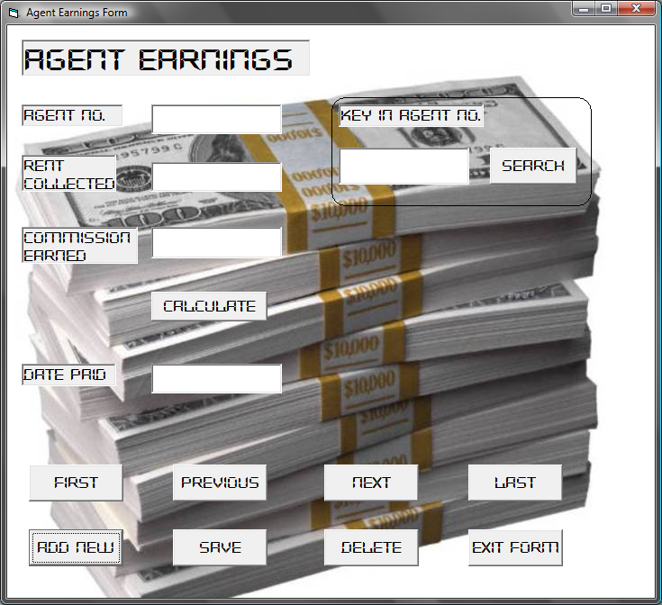

* Click the add new command and fill in the details
* Click the calculate command to find the commission earned
* Click the save button to save the record

### 3.2.4: Agents Form Manual

From the forms menu, click the agents button or press CRTL+A on the keyboard.

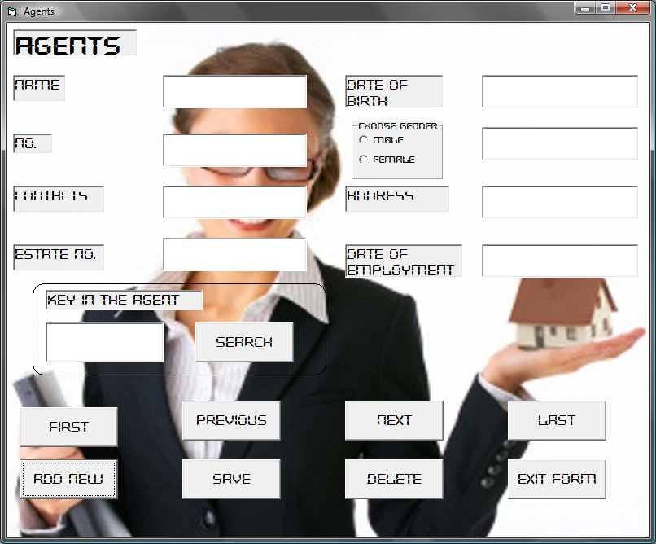

* Click the add new command.
* Fill in all the details.
* Click save command to store the record.

### 3.2.5: Company Income Form Manual

Under the form menu, click Company Income to open or press CTRL+C.

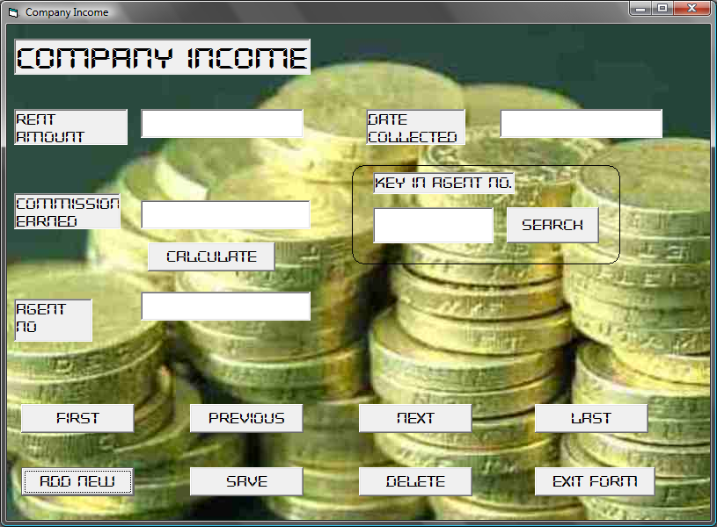

* Click the add new command.
* Fill in all the details
* Click the calculate command to find the commission.
* Click the save command.

### 3.2.6: Estate Form Manual

From the forms menu, click the estates button or press CRTL+F on the keyboard.

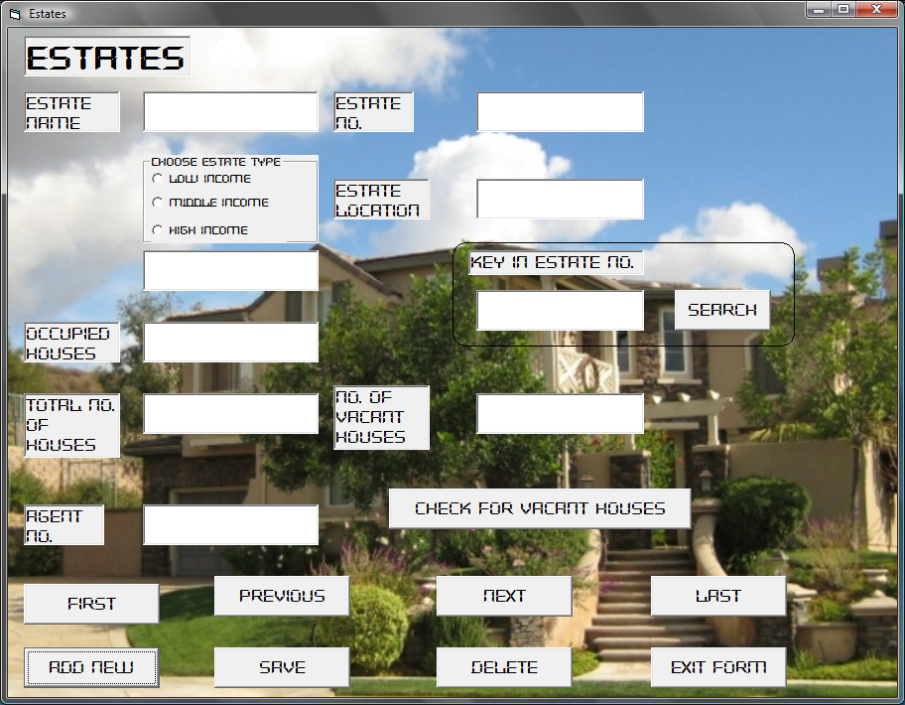

* Click the add new command.
* Fill in all the details
* Click the check for vacant houses command to find the number of vacant houses.
* Click the save command.

### 3.2.7: Remittance Form Manual

From the forms menu, click the remittance button or press CRTL+H on the keyboard.

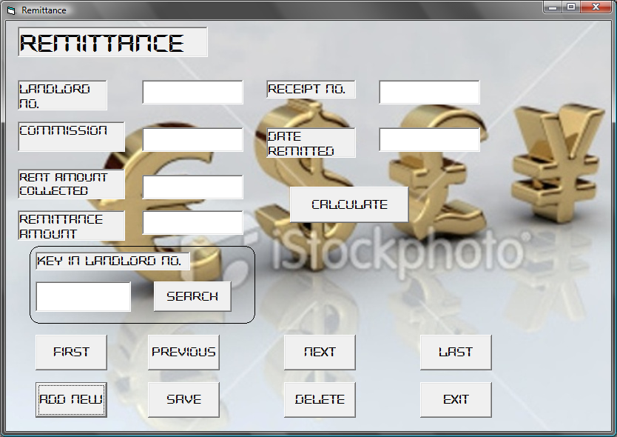

* Click the add new command.
* Fill in all the details
* Click the calculate command to find the remittance amount defaulted.
* Click the save command.

### 3.2.8: Rent Payment Form Manual

From the forms menu, click the rent payment button or press CRTL+R on the keyboard.

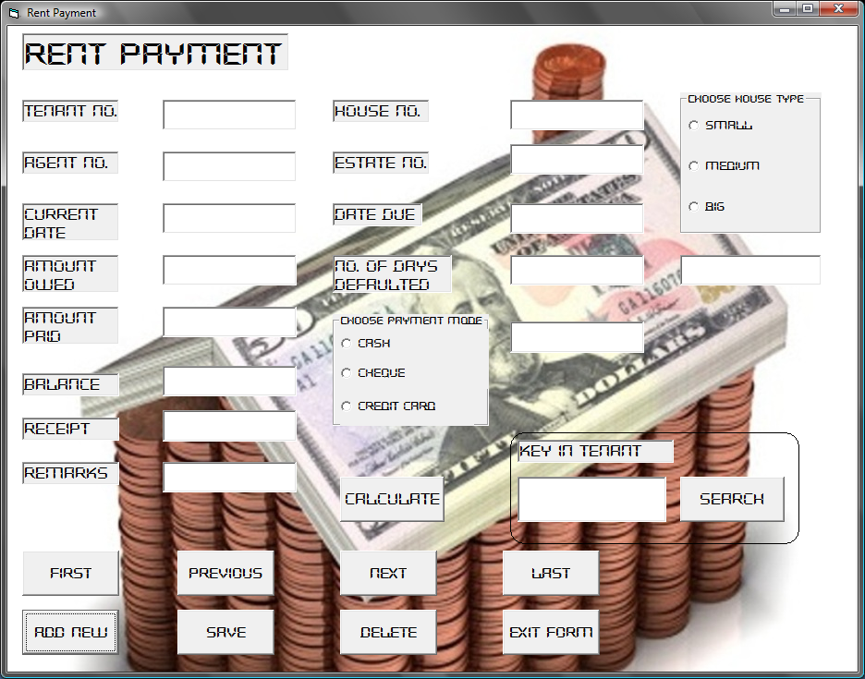

* Click the add new command.
* Fill in all the details
* Click the calculate command to find the balance and the number of days defaulted.
* Click the save command.